United Kingdom: island country located off the northwestern coast of mainland Europe. The United Kingdom comprises the whole of the island of Great Britain—which contains England, Wales, and Scotland—as well as the northern portion of the island of Ireland. The name Britain is sometimes used to refer to the United Kingdom as a whole. The capital is London, which is among the world’s leading commercial, financial, and cultural centers. Other major cities include Birmingham, Liverpool, and Manchester in England, Belfast and Londonderry in Northern Ireland, Edinburgh and Glasgow in Scotland, and Swansea and Cardiff in Wales.
The United Kingdom
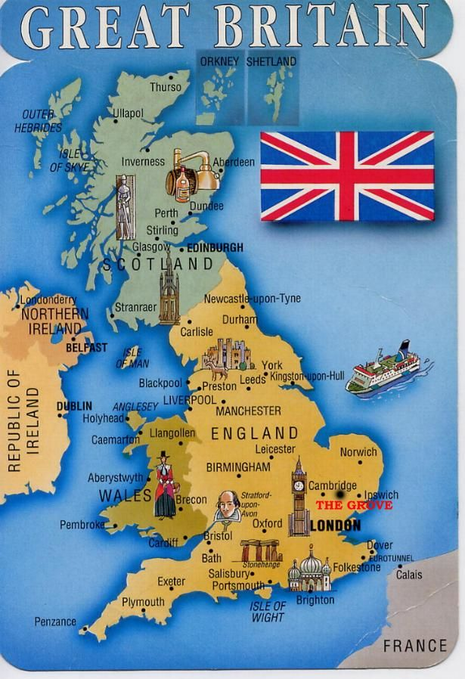
Map:
Places of interest:
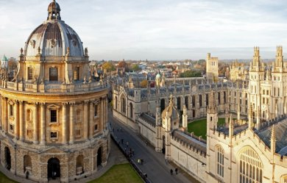
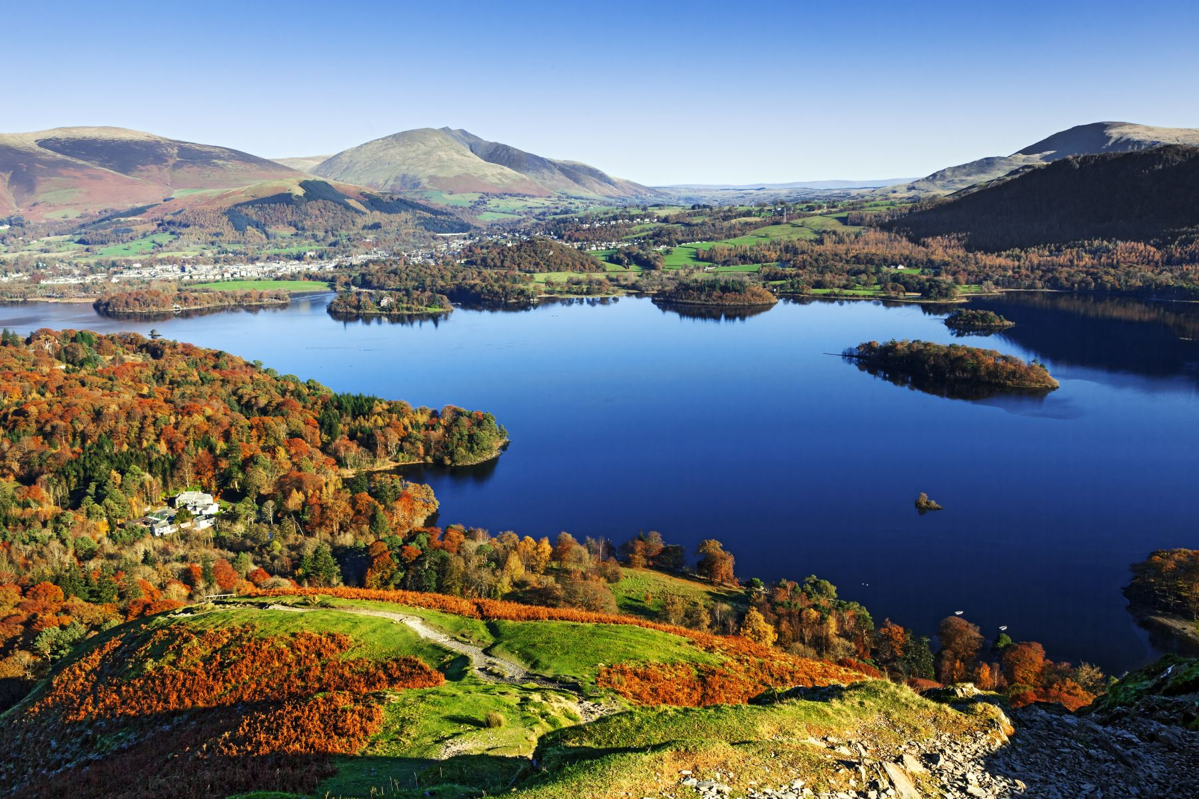
Britain has many interests post, tourists can visit. First place is London, with amazing architecture and interesting hidden parts. England is also famous for its university towns; Oxford with Oxford University and Cambridge with Cambridge University. In the centre of the country is Stratford upon Avon, the birthplace of a famous writer William Shakespeare. Next, a remarkable place in heart of England is Birmingham. Another interesting place to visit can be Liverpool or Manchester especially for fans of football. Liverpool is also a city, where the Beatles were formed. Great Britain has also many nature spots, which are worth to explore for example Snowdonia National park or Lake District. While cities all around the UK are interesting as well. Belfast, Edinburgh or Bristol can be a great choice. In the south, there is one more mysterious place which is Stonehenge, a prehistoric monument in Wiltshire, consisting of a ring of standing stones.
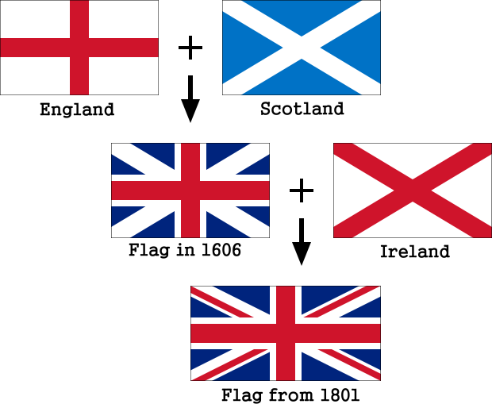
NATIONAL FLAG: The British flag, known as the Union Jack, is a combination of three flags – English, Irish and Scottish. The flag is formed by the Saint Andrew’s cross, the Saint Patrick’s cross and the Saint Gorge’s cross.
Viktória Vašičkaninová 8.A

