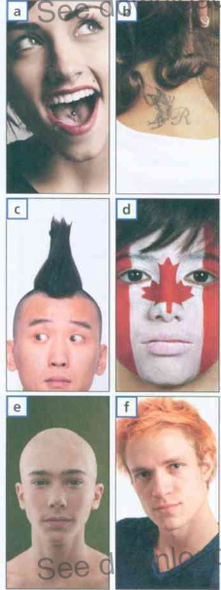
Body art
I. Match the expressions to the pictures.
- paint my face in a team´s colours _____
- have my tongue pierced _____
- dye my hair orange _____
- shave my head _____
- have an unusual hairstyle _____
- have a tattoo __b__
WOULD / WOULDN´T – ezekkel a kifejezésekkel azt fejezzük ki, mi
az, amit megcsinálnánk, és mi az amit nem vállalnánk be.
Pl. I wouldn´t hold a spider. – Nem fognék meg egy pókot.
I would shave my head. – Leborotválnám a fejem.
II. Make your own sentences – would / wouldn´t.
– Alkoss saját mondatokat. Helyettesítsd be a would / wouldn´t
kifejezéseket.
- I ……....................................... have a tattoo.
- I ……....................................... paint my face in a team´s colours.
- I ……....................................... dye my hair orange.
- I ……....................................... shave my head.
- I ……....................................... have an unusual hairstyle.
- I ……....................................... have my tongue pierced.
III. Translate the sentences. Fordítsd le a mondatokat magyarra.
- …………………………………………………………………………………………………
- …………………………………………………………………………………………………
- …………………………………………………………………………………………………
- …………………………………………………………………………………………………
- …………………………………………………………………………………………………
- …………………………………………………………………………………………………
- …………………………………………………………………………………………………

